**Referral Form**

**To be eligible for the programme, the person must be aged 18+ and:**

* Be registered to a South Yorkshire GP Practice (by postcode)
* Have an HbA1c of 42-47 mmol/ml (6.0-6.4%) or an FPG of 5.5-6.9 mmol/l tested in the last 12 months.
* Not have been diagnosed with Type 2 Diabetes.
* Not be pregnant at the time of referral.
* Be able to participate in NHS Diabetes Prevention Programme.
* ***If Previous Diagnosis of GDM*** *–* They are eligible with a HbA1c < 42 mmol/mol or FPG < 5.5mmol/l tested within the last 12 months.
* ***Where the patient is over 80 years*** *–* Tick the following box to provide written confirmation, that you consider the benefits of the programme to outweigh any potential risks associated with weight loss for the individual. 

Please fill in and send to: **Post:** Healthier You HQ, 2nd Floor, The Watson Building, 4 Renshaw St, Liverpool L1 2SA

**Email:** healthieryou.syandb@nhs.net

We can also be contacted by phone on **0800 092 1191**

# Organisational data

GP Practice name: General medical practice code:

If not known, please tick: No registered GP Practice Code not applicable Code not known

# Patient data

NHS number: First language: Ethnicity: Family name: Given name:

Postcode:

Address:

Telephone: Email:

Date of birth: Gender: Height (m.cm): Weight (kg): BMI:

EMIS ID: VISION ID: Previous GDM: Yes: No:

# Blood Test Data *The criteria extension does not change normal practice and there continues to be a requirement that all patients with NHD receive their annual review in line with NICE guidance PH38.*

Date: HbA1c: FPG: Reason for FPG:

# On Learning Disability register?

Yes: No: Not known / n/a:

**Information to be discussed when a referral is made:**

**Is the individual recorded on SMI register?**

Yes: No: Not known / n/a:

**Please sign to confirm that the patient consents to:**

* Their personal and medical information is being shared
* The programme is delivered by Reed Wellbeing, and data will be shared securely between Reed Wellbeing, NHS England and the Local Authority for the purposes of delivering the programme effectively and monitoring programme performance
* The purpose of sharing this information is for them to participate on the programme
* Their personal and medical information will be stored securely on electronic systems and not be used for any purpose other than programme delivery and monitoring
* The results of preventative diabetes screening will be shared securely with their GP
* Their information may be shared with NHS England for programme evaluation purposes only
* Their data will be treated as confidential and held, shared and disposed of in line with all legal requirements (including the General Data Protection Regulation) and NHS guidance (which includes the Caldicott Guidelines)
* Should they take up the programme, their data will be retained for the duration of the contract with NHSE.
* Should they not take up the programme, or cease to attend. Their individual data will be retained for 3 years after they have been discharged back to the care of their GP practice.

Name: Date:

**Please mark here if you are recording any additional important information overleaf**

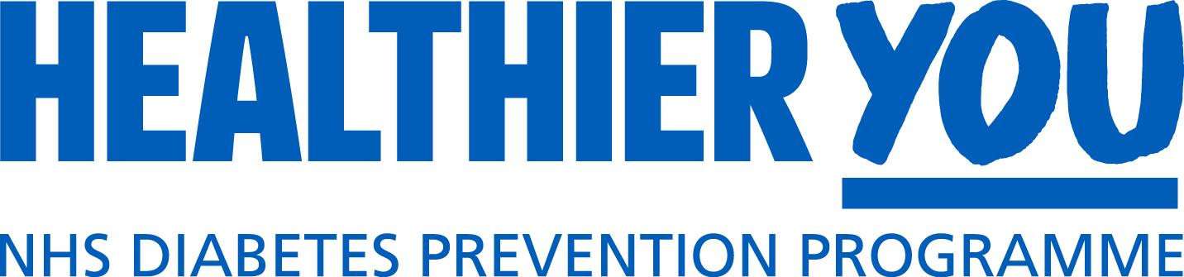

# Service provided by



