CON2_FORM

Consent Statement

The Early Help Assessment and TAC/F is a voluntary process and consent from the Child, Young Person and Family is required before the information in this assessment is shared outside of your agency.

Doncaster Safeguarding Children Board
Children and Young People’s Services

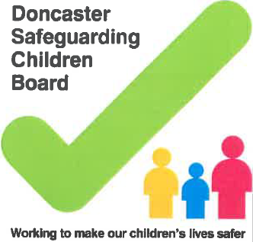
Family Consent Record
Child / Young Person’s Name & DOB:
Consent Dates
Privacy Notice Issued? (If no, please action this as soon as possible) | ☐ Yes ☐ No
Consent Decision | ☐ Child / Young Person can make his/her own decisions  and has  agreed to the Early Help Assessment  ☐ One Parent has Agreed to the Early Help  Assessment  ☐ Both parents have agreed to the Early Help  Assessment  ☐ Child / Young Person’s & Parents have agreed to the  Early Help  Assessment  ☐ Parent (s) have NOT agreed to the Early Help  Assessment  ☐ Neither child / young person nor parents have agreed  to the Early  Help Assessment  ☐ No consent sought or answered in time (open  case without consent as an emergency)  ☐ Informed consent
If proceeding with enquiry without consent please specify the reason for this | This is mandatory to be completed if consent not sought
Related Person(s) deciding on the consent
Other Person(s) Deciding on Consent
Further Details
Consent Restrictions
Consent given for ALL departments and user | ☐ Yes ☐ No
Comments
Signatures of Consent

I agree to the Early Help Assessment taking place.

I understand that the information that is relevant for my child’s / my needs will be recorded and securely stored as a paper or electronic file.

I agree that this assessment can be shared with other professionals in order to help provide and co-ordinate support to my family.
Name:
Parent / Carer / Child / YP
Signed:
Parent / Carer / Child / YP
Name:
Practitioner
Signed:
Practitioner
Date:

Note: If you are completing this as a paper version and not electronic you should send a copy to Early Help Hub along with the enquiry form.

