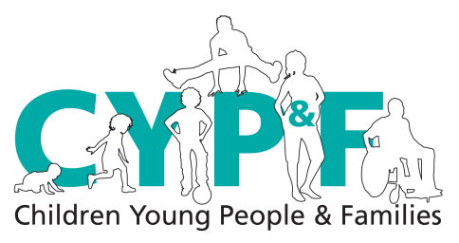

Community Children’s Nursing Team Referral Form
Anything marked with * MUST be filled in. Thank you
Please telephone 01302 379528 to discuss this referral prior to faxing. Please note 24hours notice is required for all visits.
Please complete form as fully as possible. Please fax completed form to 01302 379524.
* Name: ______________________________  * Address: ____________________________  ____________________________________  ____________________________________  *Postcode: ____________________________  * D.O.B. ______________________________  * Male: Female:  Religion: _____________________________  Ethnic group:  * Discharge address if different from above: | * NHS No: __________________________  * Home Contact No: __________________  * Mobile Contact No: __________________  Main Carer’s Name:___________________  Relationship: ________________________  *Parental Responsibility:  Other Significant Family members:  Siblings: __________________________________  * Spoken Language:
* Consultant: __________________________  GP: ________________________________  Surgery: _____________________________  * School: _____________________________  * H/V or School Nurse: | * Social Worker (current or previous):  ___________________________________  * Child Protection Plan:  CIN: EHAF: CAF: TAC:
* Reason for referral: ____________________________________  ____________________________________  ____________________________________  ____________________________________  ____________________________________  ____________________________________  *Expected date of discharge:  *First visit required on: ___________________ | * Diagnosis / relevant medical history:  ___________________________________  ___________________________________  ___________________________________  *Current weight:  Date:  (must be recorded if requesting IVABs)
* Risk assessment: (To be completed in all cases) Think –What would you like to know if visiting this family alone? Please state any concerns regarding family which might impact on staff safety: drug abuse, violence, domestic abuse etc

Patient name:  Date of Birth: | NHS Number:

Infection control Status: | Any other Health professionals involved:  Name:  Contact Details
Last 2 PEWS score:  Comments any clinical information: | Name:  Contact Details:

* Current medication:  _______________________________  _______________________________  _______________________________  _______________________________  * Allergies: _______________________ | *Equipment required (please provide at least 7days supply) : ________________________________________  ________________________________________  ________________________________________  _______________________________________  If child/young person is on IV antibiotics then medication and supplies for the duration of the course should be provided.
* Referred by: (print name)  _______________________________  * Organisation / Ward: ______________  _______________________________  * Contact number: _________________ | *Designation: ________________________________________  *Signature: ________________________________________  *Date:____________________________________
For IV Administration Only – All of the details must be completed History of how the medication has been given in hospital
Name of Drug: | Dose:
Start Date: | End Date:
Infusion: Yes No | Rate: (even if blous)
Dilution Type:  Amount: | Made up to: mls
Access Type:  Date inserted:  PICC/Hickman line measurement from tip to insertion point:  If peripheral and medication required for more than 72 hours please detail plan for change: | Type of Flush  Amount of Flush  Comments:
Date of last dressing and bung change:

Review Date: | Last 2 VIP scores: 1, 2,
All medications need to be prescribed on our community prescription chart.
To be completed by CCN team
Date received: | Named Nurse: | Accepted:  Yes:  No: | Date of First visit: | Date on TPP

Community Children’s Nursing Team Tel : 01302 379528
Cantley Health Centre, Middleham Rd, Fax : 01302 379524
Doncaster, DN4 6ED.

